RentalHouse
Full Stack MERN House Rental Platform

Functional Specification & Technical Documentation
Project Title | RentalHouse - House Rental Marketplace
Date | 27 June 2026
Team ID | TEAM-MERN-09
Platform Version | v1.0.0

1. Introduction
RentalHouse is a modern, responsive full-stack MERN (MongoDB, Express.js, React.js, Node.js) web application designed to simplify the process of listing, discovering, and booking residential rentals. Traditional real estate processes are characterized by lack of transparency, exorbitant brokerage fees, outdated listings, and unsafe visitor coordination. RentalHouse removes intermediaries, connecting property owners and prospective tenants directly to enable verified, direct communication.
Project Roles and Team Assignments:
- Project Team (Full-Stack Developer): Responsible for React client, Express API REST services, local database persistence, and integration testing.

2. Project Overview
The primary goal of the RentalHouse platform is to democratize the home rental experience. Owners can list their properties for free with accurate descriptions, photos, and geographical coordinates. Tenants can search, filter, and compare listings side-by-side, and submit visit booking requests without facing broker fees.
Key Features:
- Role-Based Dashboards: Custom analytics interfaces for Tenants (bookings, wishlists), Owners (listing analytics, visit inquiries, uploads), and Admins (system statistics, user moderation, status overrides).
- Sticky Property Compare Drawer: Compare up to 3 listings side-by-side to contrast rent, deposit, bedrooms, bathrooms, and area.
- Direct Booking Coordination: Integrated scheduling where tenants request physical visits and owners accept or reject them.
- Google Maps Visualizations: Embedded maps based on latitude and longitude parameters for realistic location tracking.
- Local Persistence Fallback: Automatic server adaptation using MongoMemoryServer to run local database instances dynamically when Atlas connection is restricted.

3. Architecture
RentalHouse utilizes a decoupled, 3-tier client-server architecture. The frontend React single page application communicating via Axios client wrapper to the Express API server, which performs validation and interfaces with MongoDB database.
System Architecture Diagram:
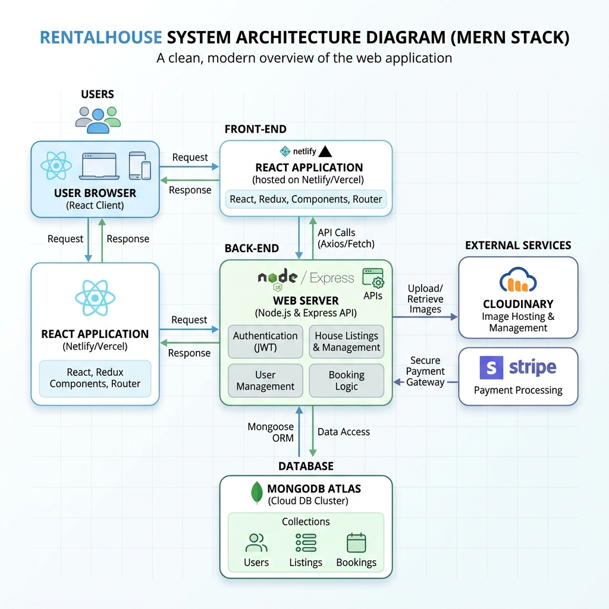
Figure 3.1: RentalHouse 3-Tier System Architecture (Light Theme)

Architecture Layers:
- Frontend Tier: Single Page Application (SPA) bootstrapper compiled with Vite. Utilizes React 19, Context API for global state (Auth, Theme, Property), Bootstrap 5 for visual CSS controls, and Axios for async JSON transfers.
- Application Backend Tier: Node.js runtime executing Express.js framework. Handles routing, session parsing, uploads middleware, CORS, and centralized database query mapping.
- Database Tier: MongoDB NoSQL document database. Interfaces via Mongoose ODM for schemas validation, models mapping, and relational query populations.

4. Setup Instructions
Prerequisites:
- Node.js runtime environment (v16.0.0 or higher)
- npm package manager (v8.0.0 or higher)
- Modern web browser (Chrome, Edge, Firefox)
Installation Steps:
1. Clone/Extract the project folder to your local directory.
2. Navigate to the backend server directory: `cd server`
3. Install backend dependencies: `npm install`
4. Create/Verify the environment variables config: Verify that the `server/.env` file contains your port, JWT secrets, and connection parameters.
5. Navigate to the frontend client directory: `cd ../client`
6. Install frontend dependencies: `npm install`

5. Folder Structure
The codebase is organized cleanly into backend and frontend directories:
houserent/
├── client/ React frontend application client stack
│ ├── src/api/ Axios instances and endpoint configurations
│ ├── src/components/ Reusable layout headers, skeleton loaders, compare tray overlays
│ ├── src/context/ Global contexts (AuthContext, ThemeContext, PropertyContext, FavoritesContext)
│ ├── src/pages/ Views (Home, Browse, details, Dashboards, Authentication forms)
│ ├── src/index.css Global CSS styling system (Harmonized HSL palette)
│ ├── App.jsx / main.jsx App routers and entry hooks
├── server/ Express Node backend server stack
│ ├── config/ MongoDB connection logic and local database fallbacks
│ ├── controllers/ Route controllers handling auth, properties, bookings, favorites, admin controls
│ ├── middleware/ Auth checking, multer file uploads, and global error middleware
│ ├── models/ Mongoose Schema collections (User, Property, Booking, Favorite, Review)
│ ├── routes/ Express route configuration mappings
│ ├── scripts/ DB seeding script populate logic
│ ├── app.js / server.js Express server and DNS settings entry scripts

6. Running the Application
Follow these commands to run both the frontend and backend servers simultaneously:
Start Backend Server:
cd server
npm run dev
Note: The server will automatically bind to http://localhost:5000.
Start Frontend Client:
cd client
npm run dev
Note: The React client will bind to http://localhost:5173.

7. API Documentation
The backend REST API provides the following endpoints:
HTTP Method | Endpoint URL | Access | Description
POST | /api/auth/register | Public | Create a new user (Tenant, Owner, or Admin)
POST | /api/auth/login | Public | Authenticate user and return JWT session cookie
GET | /api/auth/me | Private | Get active user session profile data
GET | /api/properties | Public | Browse and search properties with query filters
POST | /api/properties | Private (Owner) | List a new residential property
GET | /api/properties/:id | Public | Get comprehensive details and reviews of a property
POST | /api/bookings | Private (Tenant) | Submit a visit booking request inquiry
PUT | /api/bookings/:id | Private (Owner) | Accept or reject a pending visit request
GET | /api/admin/stats | Private (Admin) | Get platform metadata, listings, and user statistics

8. Authentication
Authentication is implemented using JSON Web Tokens (JWT). When a user registers or logs in, a JWT payload containing their user ID and role is generated and encrypted. This token is transmitted to the client and stored in local storage, and is also verified on the server for all protected routes using custom middleware.
Security Controls:
- Password Encryption: Passwords are salted and hashed using Bcryptjs prior to database persistence.
- Route Protection Middleware: Express auth middleware verifies the Authorization header. Admin and Owner specific controllers are wrapped in role guards to verify credentials.

9. User Interface
RentalHouse features a light-themed interface built on top of Bootstrap 5 CSS components:
Homepage:
Displays the search bar, filter controls, and the property cards. Fully responsive grid structure.
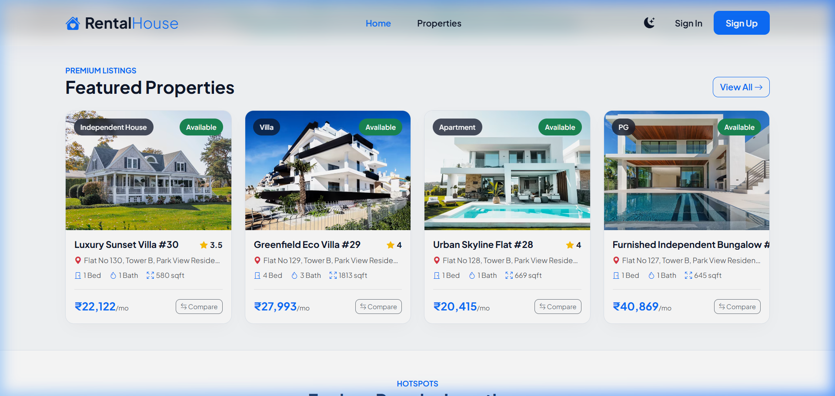

Login Screen:
Authentication form supporting role-specific workflows.
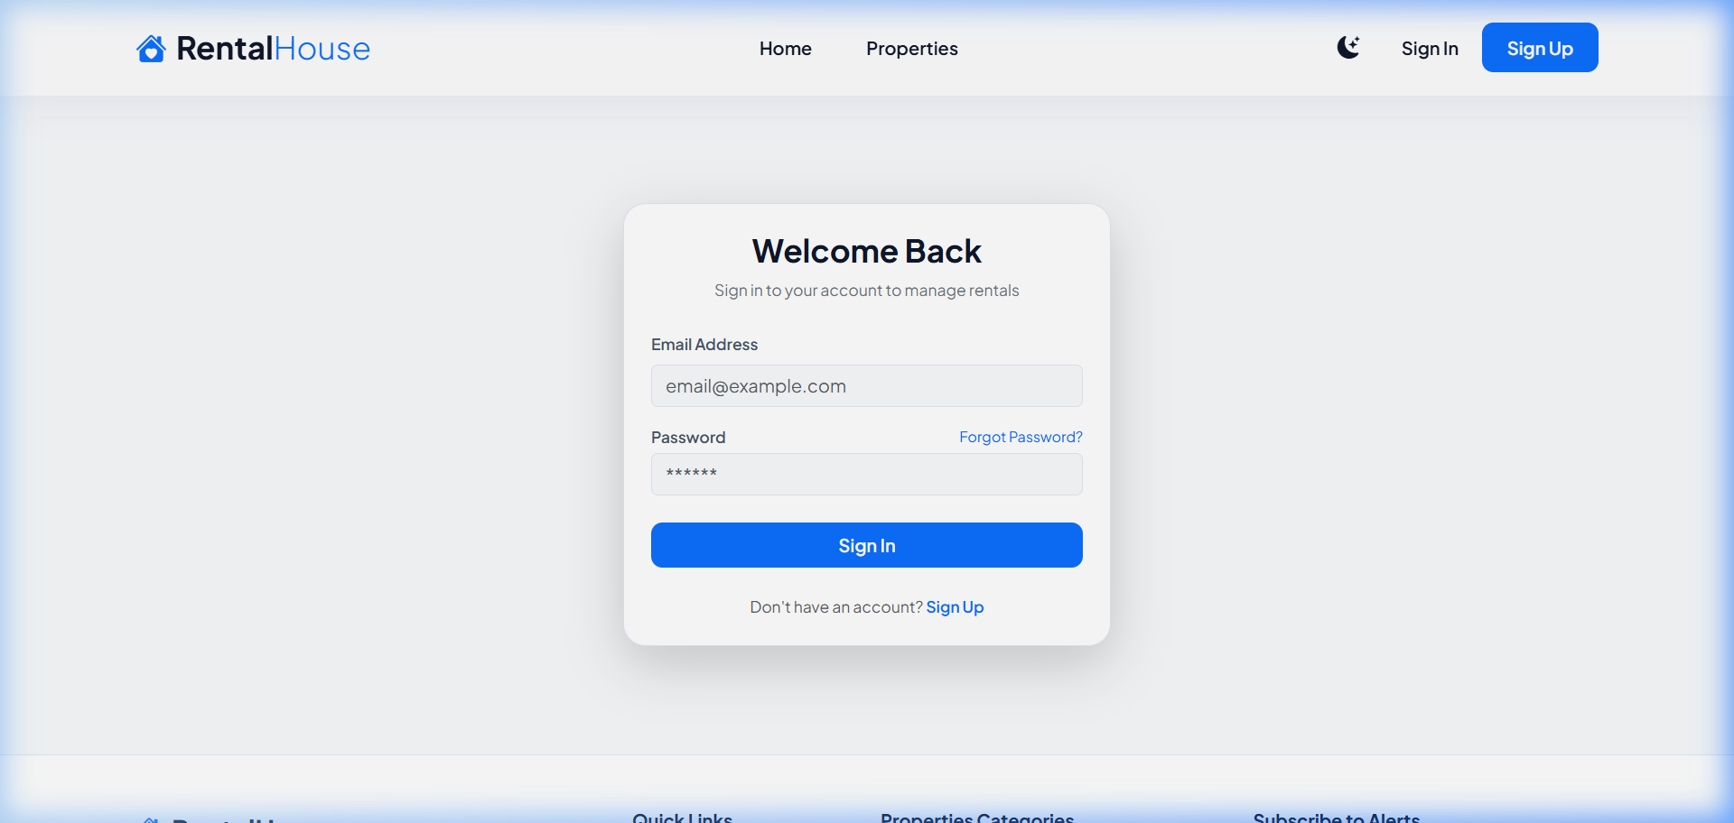

Property Details Page:
Detailed view containing listing metrics, image galleries, reviews, and booking prompts.
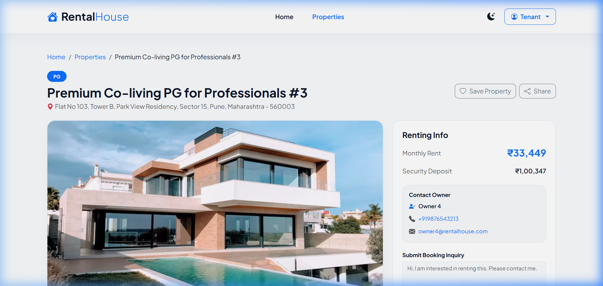

Add Property Form:
Multi-input form allowing owners to specify property parameters and upload photos.
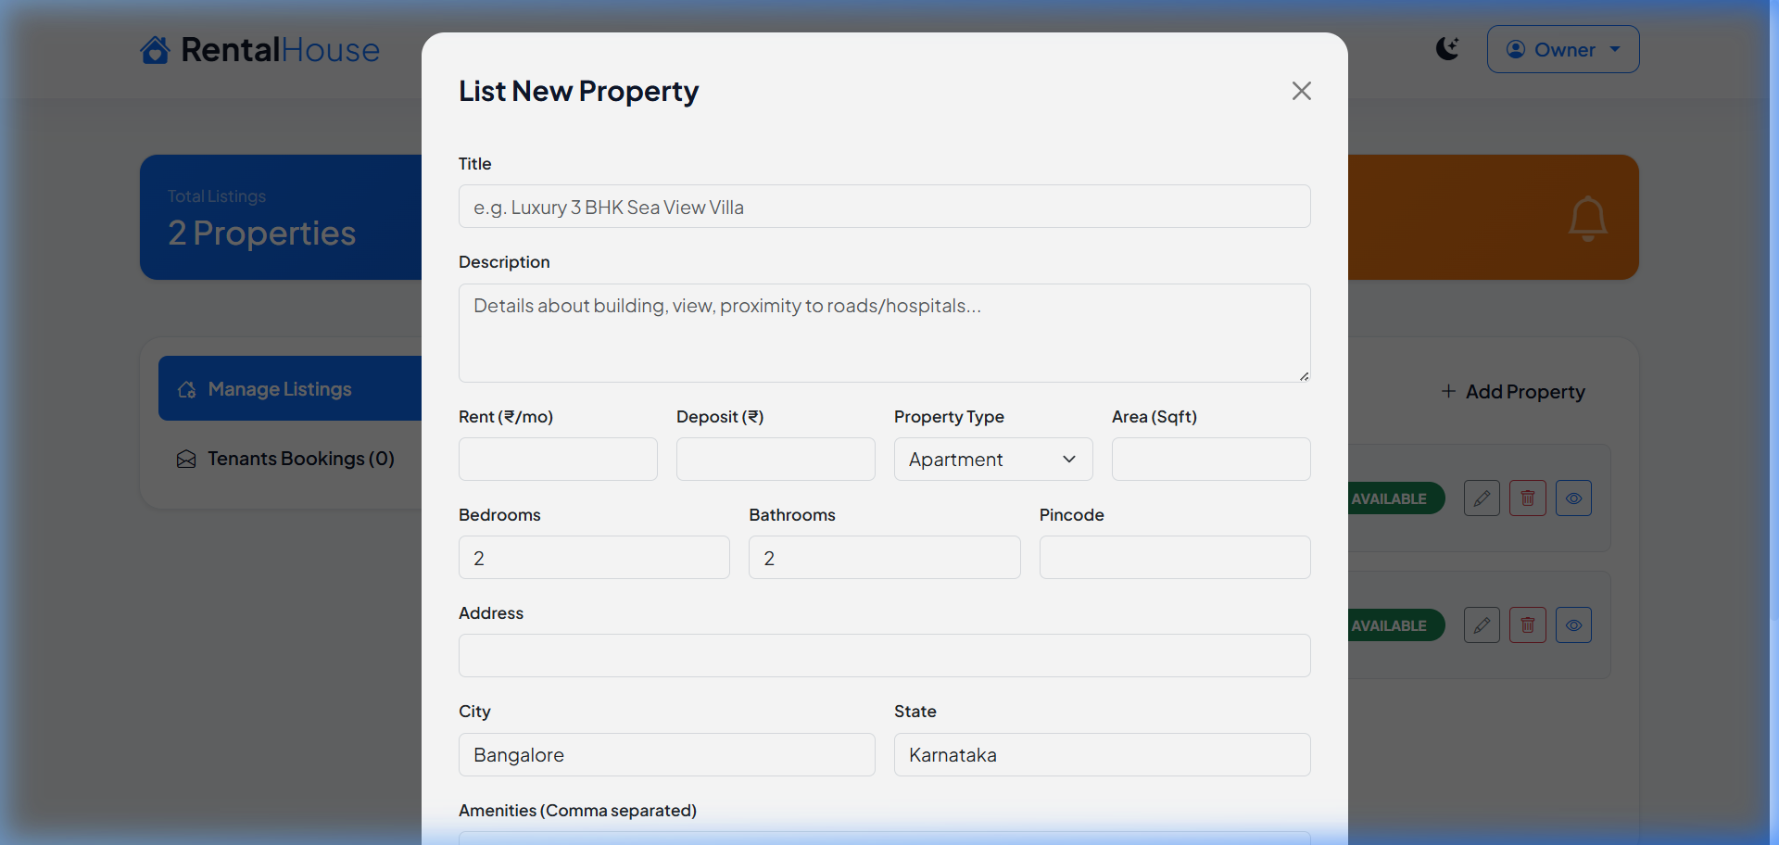

10. Testing
Manual integration tests were performed across various modules. High-priority user acceptance validation cases were mapped out in the FSD testing documentation, including Tenant signup, Owner listing uploads, visit bookings, and admin panel moderation.
Critical Bug Resolution:
During local startup, a network exception was identified where connection to the remote MongoDB Atlas cluster was denied due to IP Whitelisting restrictions. To ensure zero setup out-of-the-box, a local persistence fallback was implemented. If connection attempts to Atlas timeout (5 seconds), the server dynamically invokes `MongoMemoryServer` using local directories (`/server/.local-db`), starts a local MongoDB process, and seeds it with default listings.

11. Screenshots or Demo
Below are the verified screenshots of the dashboard user interfaces for different roles:
Tenant Dashboard:
Shows current favorite property listings, wishlists, and pending/approved visit inquiry requests.
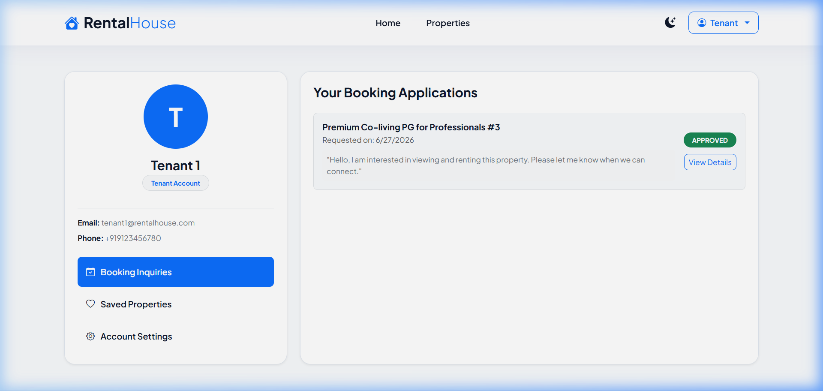

Owner Dashboard:
Provides metrics like active properties listed, inquires received, listing status management, and booking approvals.
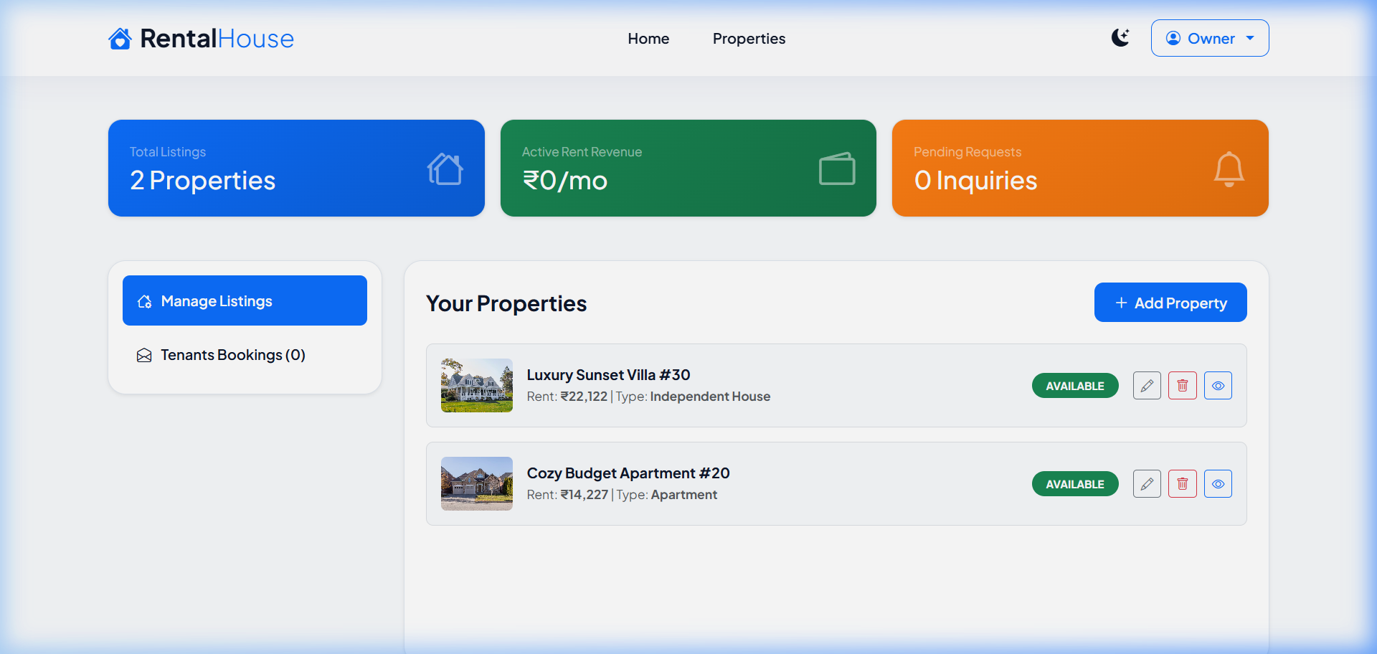

Admin Dashboard:
Shows platform-wide statistics (total properties, total bookings, user counts) and lists users with block/unblock tools.
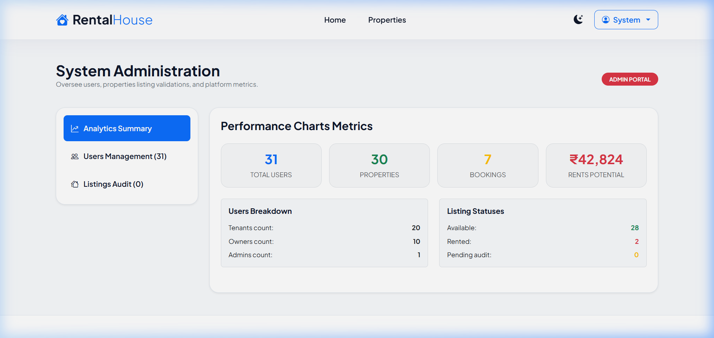

12. Known Issues
1. Cloudinary Integration: If Cloudinary credentials are not configured in the `.env` file, image uploads fallback to saving files on the local filesystem (`/server/uploads`). A console warning is logged, but the application continues functioning.
2. Email Notifications: If SMTP parameters are empty, Nodemailer triggers are skipped, and email contents are written directly to the backend terminal log for debugging.

13. Future Enhancements
- Real-time Chat: Implementation of WebSocket-based chat between tenants and owners inside the dashboards.
- Payment Gateway Integration: Online deposit escrow payments using secure gateways.
- Automated Tenancy Agreements: Automatic PDF tenancy lease generation and e-signing using DocuSign APIs.

